Assignment 11.1

- Transfer data between Mysql and HDFS using sqoop.

Installing mysql:

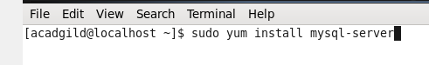

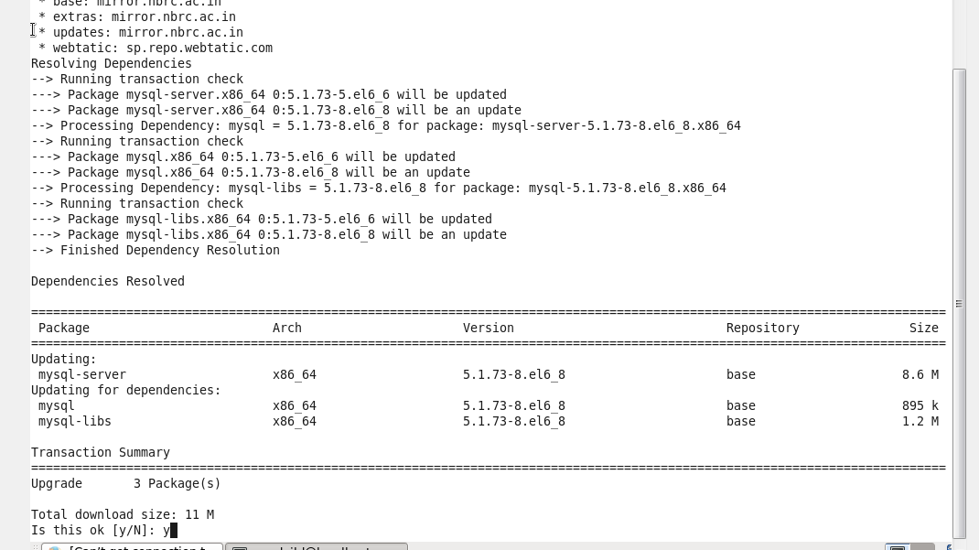

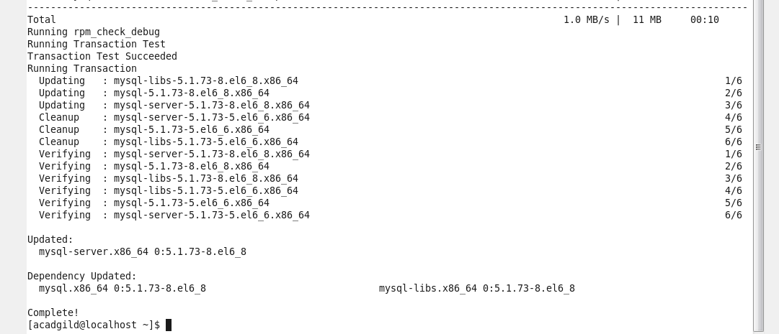

Now mysql download is completed, below command is used to start mysql services…

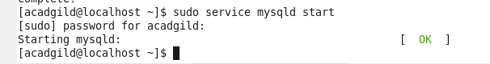

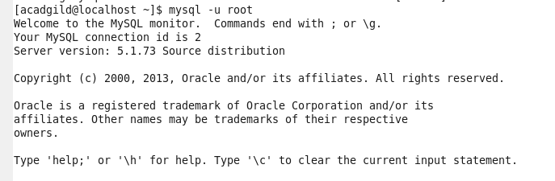

Creating a new database in MYSQL instance and also created table named ‘acad’:

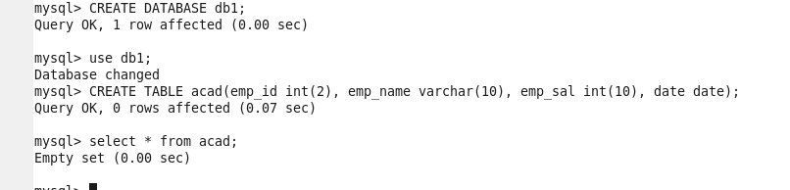

Describing a table created:

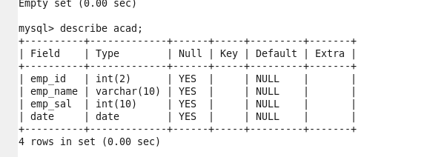

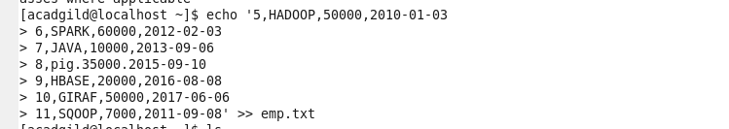

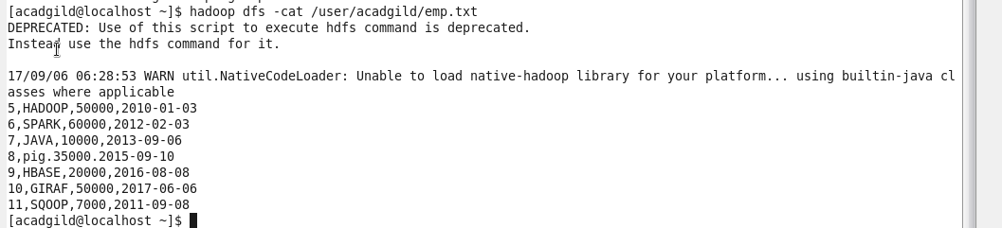

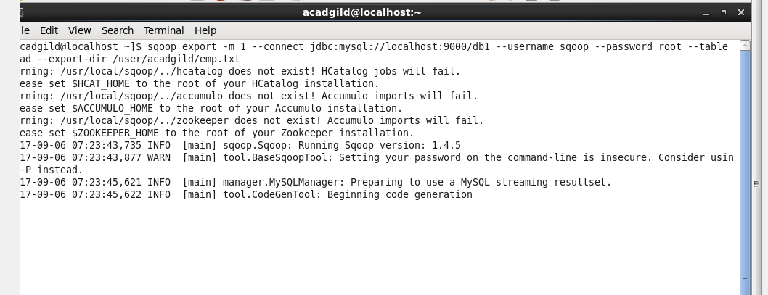

Above line is getting executed from long time…

- Transfer data between Mysql and Hive using sqoop.

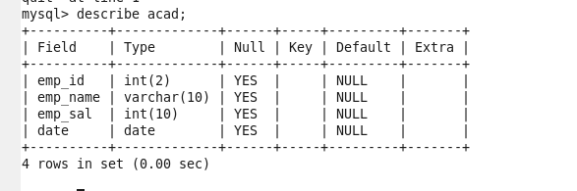

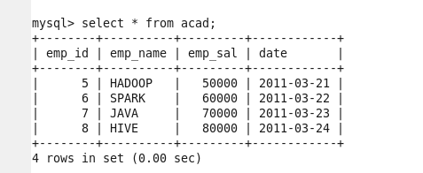

Granting all permissions to Root and Flush the privileges:

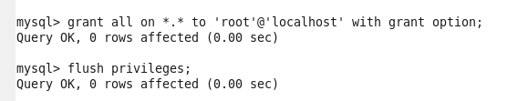

Below sqoop command to transfer selected columns from MYSQL to Hive:

